**STORE DATA**

***Chart Requirements :***

1. ***Total sales and Total orders monthly***
2. ***Top 10 states having highest sales***
3. ***Percentage of sales : Men Vs Women***
4. ***Total sales based on Order status***
5. ***Total sales based on Age & Gender***
6. ***Highest selling category***
7. ***Percentage of sales : Channel***

**SQL QUERIES**

1. **Total sales & orders monthly**

***select month,sum(amount) as total_sales, count(order_ID) as total_orders from store_data***

***group by Month***

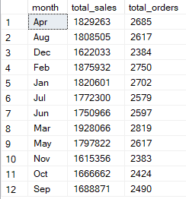

1. **Top 10 states having highest sales**

***select top 10 ship_state , sum(amount) as total_amount from store_data***

***group by ship_state***

***order by sum(amount) desc***

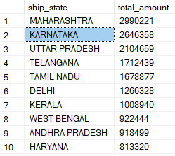

1. **Percentage of sales : Men Vs Women**

***select gender,sum(amount) * 100 / (select sum(amount) from store_data) as "% of sales "from store_data***

***group by gender***

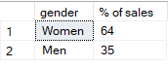

1. **Total sales (orders) based on Order Status**

***select status, count(order_id) as total_orders from store_data***

***group by status***

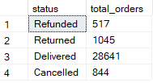

1. **Total sales based on Age & Gender**

***select gender, age_group , sum(amount) as total_sales from store_data***

***group by age_group,gender***

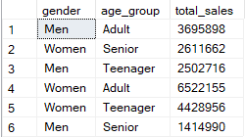

1. **Highest selling category**

***select category, sum(qty) as total_sales from store_data***

***group by category***

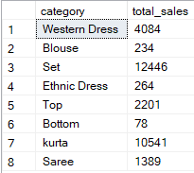

**7.Percentage of sales : Channel**

***select channel , cast(sum(Amount)*100 / (Select sum(Amount) from store_data) as decimal(10,2))***

***as "% of total_Sales" from store_data***

***group by channel***

